Brianna Lee

Professor Labouseur

CMPT 308N

12 November 2020

Lab 8 – Lee

1. 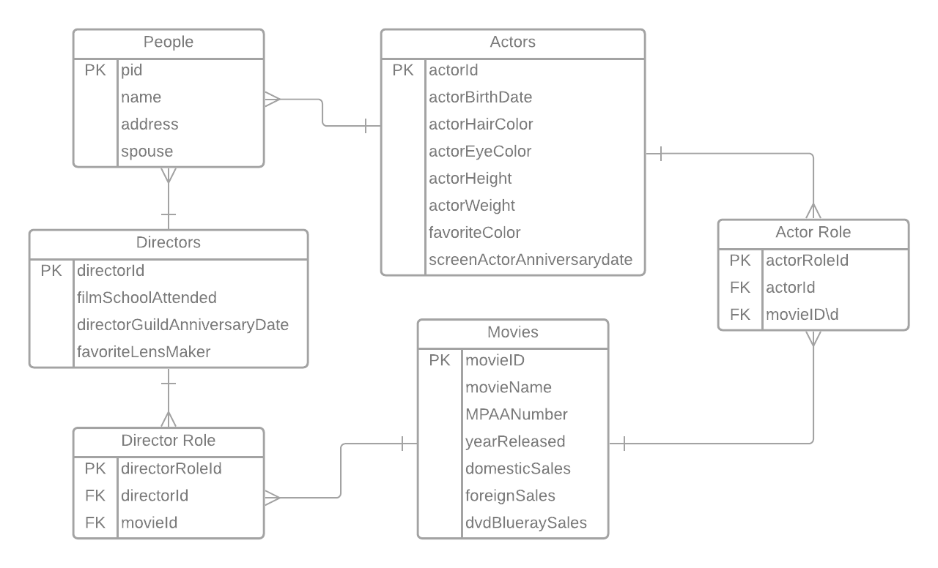
2. Look at the SQL file attached.
3. Functional Dependencies:

People Table – name, address, and spouse are dependent on the pid

Directors Table – filmSchoolAttended, directorGuildAnniversaryDate, and favoriteLensMaker are all dependent on the directorId

Actors Table – actorBirthDate, actorHairColor, actorEyeColor, actorHeight, actorWeight, and screenActorAnniversaryDate are all dependent on the actorId

Director Role Table – directorId and movieId are both dependent on the directorRoleId

Actor Role Table – actorId and movieId are both dependent on the actorRoleTable

1. Query to show all the directors with whom actor “Roger Moore” has worked – also in the SQL file attached.

